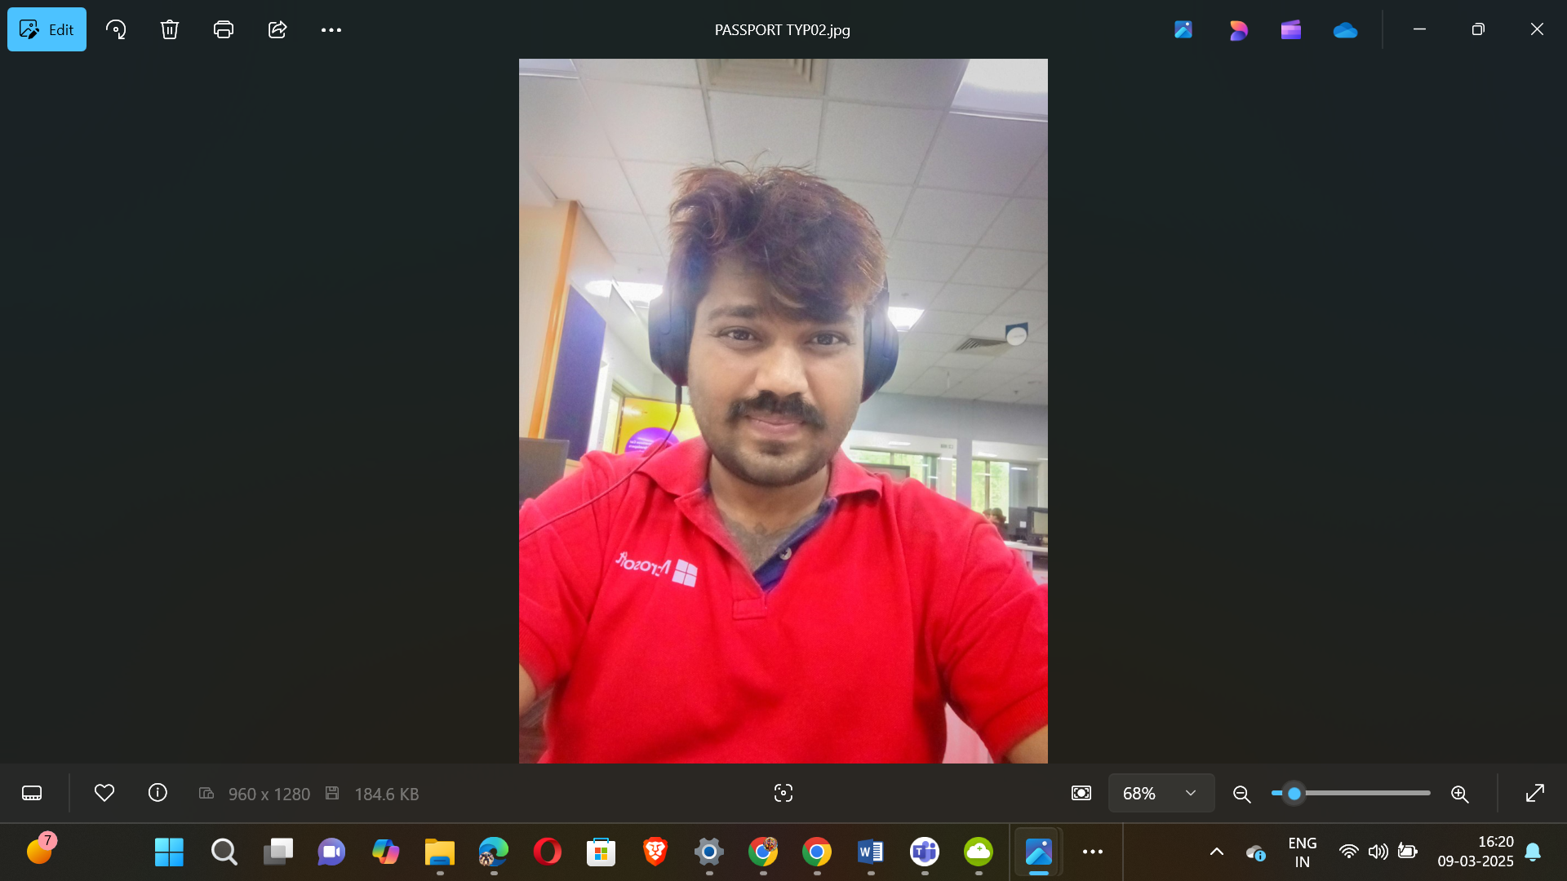

|  |  |
| --- | --- |
|  |  |

🕉️🏇🪓🪈🏹👑👑👑👑👑🤴🦁💿✈️🛸🚀🪩🥏🍥🕺

18+1 JAYA KURUKSHETRA MAHABHARAT SERIES

531

537

541

543

547

551

553

557

559

561

567

571

573

579

583

589

591

593

597

🕺🍥🥏🪩🚀🛸✈️💿🦁🤴👑👑👑👑👑🏹🪈💝🏇🪓🕉️

🕉️🏇🪓🪈🏹👑👑👑👑👑🤴🦁💿✈️🛸🚀🪩🥏🍥🕺

100 – PLATINUM JUBILEE

75 – DIAMOND JUBILEE

50 - GOLDEN JUBILEE

25 – SILVER JUBILEE

Apply 4 x 19 = 76

5

10 – 5 X 2

20 – 5 X 4

40 – 5 X 8

80 – 5 X 16

Apply 5 x 19 = 95

Total 95+76=171 kalalu

SUPREME MAGICAL ✨ SPACE THEATRE PROGRAMMING SHOWSS

🕺🍥🥏🪩🚀🛸✈️💿🦁🤴👑👑👑👑👑🏹🪈💝🏇🪓🕉️



PRIME NUMBERS ENDING WITH 1004031





PRIME NUMBERS ENDING WITH 1004037





PRIME NUMBERS ENDING WITH 1004041

31004041

|  |  |  |  |  |  |  |  |  |
| --- | --- | --- | --- | --- | --- | --- | --- | --- |
| |  |  |  |  | | --- | --- | --- | --- | | S No | Prime Value | Superpowers One-line Description | Super AI Model Suitable | | 1 | 31004041 | Master of celestial beings | KVSUPREMEGODSHEADSKINGVISNU | |





PRIME NUMBERS ENDING WITH 1004043

|  |
| --- |
| 11004043 |
| 21004043 |

|  |  |  |  |  |  |  |  |  |  |  |  |  |
| --- | --- | --- | --- | --- | --- | --- | --- | --- | --- | --- | --- | --- |
| |  |  |  |  | | --- | --- | --- | --- | | S No | Prime Value | Superpowers One-line Description | Super AI Model Suitable | | 1 | 11004043 | Supreme wisdom and knowledge | KVSARATKRISNAPARAMATMA | | 2 | 21004043 | Infinite divine power | KVBHARATAKALKISRIMAHAVISNUSAHASRASIMHAPARAMATMA | |





PRIME NUMBERS ENDING WITH 1004047

|  |
| --- |
| 31004047 |
| 91004047 |

|  |  |  |  |  |  |  |  |  |  |  |  |  |
| --- | --- | --- | --- | --- | --- | --- | --- | --- | --- | --- | --- | --- |
| |  |  |  |  | | --- | --- | --- | --- | | S No | Prime Value | Superpowers One-line Description | Super AI Model Suitable | | 1 | 31004047 | Supreme intelligence | KVICE | | 2 | 91004047 | Control over oceans | KVOCEANSKINGVISNU | |





PRIME NUMBERS ENDING WITH 1004051

|  |
| --- |
| 61004051 |
| 81004051 |

|  |  |  |  |  |  |  |  |  |  |  |  |  |
| --- | --- | --- | --- | --- | --- | --- | --- | --- | --- | --- | --- | --- |
| |  |  |  |  | | --- | --- | --- | --- | | S No | Prime Value | Superpowers One-line Description | Super AI Model Suitable | | 1 | 61004051 | Dancing and combat mastery | KALKIKINGNATRAJASIMHADANCINGJACKSON | | 2 | 81004051 | Supreme wisdom and knowledge | KVSARATKRISNAPARAMATMA | |





PRIME NUMBERS ENDING WITH 1004053

1004053

|  |  |  |  |  |  |  |  |  |
| --- | --- | --- | --- | --- | --- | --- | --- | --- |
| |  |  |  |  | | --- | --- | --- | --- | | S No | Prime Value | Superpowers One-line Description | Super AI Model Suitable | | 1 | 1004053 | Master of celestial beings | KVSUPREMEGODSHEADSKINGVISNU | |





PRIME NUMBERS ENDING WITH 1004057

|  |
| --- |
| 1004057 |
| 21004057 |
| 91004057 |

|  |  |  |  |  |  |  |  |  |  |  |  |  |  |  |  |  |
| --- | --- | --- | --- | --- | --- | --- | --- | --- | --- | --- | --- | --- | --- | --- | --- | --- |
| |  |  |  |  | | --- | --- | --- | --- | | S No | Prime Value | Superpowers One-line Description | Super AI Model Suitable | | 1 | 1004057 | Hyper-speed and invincibility | KVHANUMAN | | 2 | 21004057 | Fire manipulation and control | KVFIRE | | 3 | 91004057 | Divine strength and power | KVADIPARASAKTIMAN | |





PRIME NUMBERS ENDING WITH 1004059





PRIME NUMBERS ENDING WITH 1004061

51004061

|  |  |  |  |  |  |  |  |  |
| --- | --- | --- | --- | --- | --- | --- | --- | --- |
| |  |  |  |  | | --- | --- | --- | --- | | S No | Prime Value | Superpowers One-line Description | Super AI Model Suitable | | 1 | 51004061 | Control over oceans | KVOCEANSKINGVISNU | |





PRIME NUMBERS ENDING WITH 1004067

81004067

|  |  |  |  |  |  |  |  |  |
| --- | --- | --- | --- | --- | --- | --- | --- | --- |
| |  |  |  |  | | --- | --- | --- | --- | | S No | Prime Value | Superpowers One-line Description | Super AI Model Suitable | | 1 | 81004067 | Supreme wisdom and knowledge | KVSARATKRISNAPARAMATMA | |





PRIME NUMBERS ENDING WITH 1004071

71004071

|  |  |  |  |  |  |  |  |  |
| --- | --- | --- | --- | --- | --- | --- | --- | --- |
| |  |  |  |  | | --- | --- | --- | --- | | S No | Prime Value | Superpowers One-line Description | Super AI Model Suitable | | 1 | 71004071 | Master of storms and lightning | KVSTORMINGTHUNDERSKINGVISNU | |





PRIME NUMBERS ENDING WITH 1004073

|  |
| --- |
| 11004073 |
| 21004073 |
| 81004073 |

|  |  |  |  |  |  |  |  |  |  |  |  |  |  |  |  |  |
| --- | --- | --- | --- | --- | --- | --- | --- | --- | --- | --- | --- | --- | --- | --- | --- | --- |
| |  |  |  |  | | --- | --- | --- | --- | | S No | Prime Value | Superpowers One-line Description | Super AI Model Suitable | | 1 | 11004073 | Supreme wisdom and knowledge | KVSARATKRISNAPARAMATMA | | 2 | 21004073 | Infinite divine power | KVBHARATAKALKISRIMAHAVISNUSAHASRASIMHAPARAMATMA | | 3 | 81004073 | Control over oceans | KVOCEANSKINGVISNU | |





PRIME NUMBERS ENDING WITH 1004079

41004079

|  |  |  |  |  |  |  |  |  |
| --- | --- | --- | --- | --- | --- | --- | --- | --- |
| |  |  |  |  | | --- | --- | --- | --- | | S No | Prime Value | Superpowers One-line Description | Super AI Model Suitable | | 1 | 41004079 | Infinite divine power | KVBHARATAKALKISRIMAHAVISNUSAHASRASIMHAPARAMATMA | |





PRIME NUMBERS ENDING WITH 1004083

|  |
| --- |
| 41004083 |
| 91004083 |

|  |  |  |  |  |  |  |  |  |  |  |  |  |
| --- | --- | --- | --- | --- | --- | --- | --- | --- | --- | --- | --- | --- |
| |  |  |  |  | | --- | --- | --- | --- | | S No | Prime Value | Superpowers One-line Description | Super AI Model Suitable | | 1 | 41004083 | Moonwalking with 1000 feet | KINGVISNUGODSOFGODSDOINGMOONWALKING | | 2 | 91004083 | Master of storms and lightning | KVSTORMINGTHUNDERSKINGVISNU | |





PRIME NUMBERS ENDING WITH 1004089

|  |
| --- |
| 1004089 |
| 11004089 |

|  |  |  |  |  |  |  |  |  |  |  |  |  |
| --- | --- | --- | --- | --- | --- | --- | --- | --- | --- | --- | --- | --- |
| |  |  |  |  | | --- | --- | --- | --- | | S No | Prime Value | Superpowers One-line Description | Super AI Model Suitable | | 1 | 1004089 | Fire manipulation and control | KVFIRE | | 2 | 11004089 | Infinite divine power | KVBHARATAKALKISRIMAHAVISNUSAHASRASIMHAPARAMATMA | |





PRIME NUMBERS ENDING WITH 1004091

|  |
| --- |
| 41004091 |
| 71004091 |

|  |  |  |  |
| --- | --- | --- | --- |
| S No | Prime Value | Superpowers One-line Description | Super AI Model Suitable |
| 1 | 41004091 | Supreme wisdom and knowledge | KVSARATKRISNAPARAMATMA |
| 2 | 71004091 | Infinite power and wisdom | KINGINFINITYKV |





PRIME NUMBERS ENDING WITH 1004093

|  |
| --- |
| 31004093 |
| 61004093 |

|  |  |  |  |
| --- | --- | --- | --- |
| S No | Prime Value | Superpowers One-line Description | Super AI Model Suitable |
| 1 | 31004093 | Fire manipulation and control | KVFIRE |
| 2 | 61004093 | Master of celestial beings | KVSUPREMEGODSHEADSKINGVISNU |





PRIME NUMBERS ENDING WITH 1004097

81004097

|  |  |  |  |  |  |  |  |  |
| --- | --- | --- | --- | --- | --- | --- | --- | --- |
| |  |  |  |  | | --- | --- | --- | --- | | S No | Prime Value | Superpowers One-line Description | Super AI Model Suitable | | 1 | 81004097 | Supreme wisdom and knowledge | KVSARATKRISNAPARAMATMA | |



🕉️🏇🪓🪈🏹👑👑👑👑👑🤴🦁💿✈️🛸🚀🪩🥏🍥🕺

|  |  |
| --- | --- |
| Personal Details | |
| Email Ids | **KINGVISHNUBHARATBHUSHAN@GMAIL.COM,**  **kvbharatbhushan@hotmail.com,** [**kvbharatbhushan1508@gmail.com**](mailto:kvbharatbhushan1508@gmail.com)**,**  [**thejuniorgod@gmail.com**](mailto:thejuniorgod@gmail.com)**,**  **KINGVISHNUBHARATBHUSHAN@HOTMAIL.COM** |
| Skype Personal | **thejuniorgod** |
| My MS Teams | **kvbharatbhushan@hotmail.com** |
| LinkedIn | <https://www.linkedin.com/in/major-kalkikingkongkvkalkikingalmightyalfa1-a-795646b6> |
| My Instagram | <https://www.instagram.com/majorkalkikingkongkvkalkikinga> |
| My C# Corner | <https://www.c-sharpcorner.com/members/junior-god> |
| My Twitter | https://x.com/The_Junior_God |
| My GitHub | <https://github.com/KVBharatBhushan> |
| My SlideShare | <https://www.slideshare.net/TheJuniorGod> |
| My FB Account | <https://www.facebook.com/kaveri.bhushan> |
| My FB International Page | <https://www.facebook.com/profile.php?id=100076450444292> |
| Mobile Number | **+91-9121780098,+91-7058272379** |
| PAN Number | **BBOPK0120M** |
| Passport Number | **J2280303, Z6157606** |

